DSA1604-KNOWLEDGE ENGINEERING
S.CHANDRA SHEKHAR REDDY
192372164
LAB EXPERIMENTS

EXP-1:Knowledge Representation Using Python
AIM: To represent facts about a student using a Python dictionary and display the stored
knowledge.
Software Required: Python 3.x
Procedure / Algorithm:
1. Create a dictionary containing student attributes.
2. Traverse the dictionary using items().
3. Display each attribute and its value.
Program
Student = {
&quot;name&quot;: &quot;Arun&quot;,
&quot;department&quot;: &quot;CSE&quot;,
&quot;course&quot;: &quot;Python Programming&quot;,
&quot;year&quot;: 2
}
print(&quot;Student Knowledge Representation&quot;)
for key, value in student.items():
print(key, &quot;:&quot;, value)
OUTPUT:
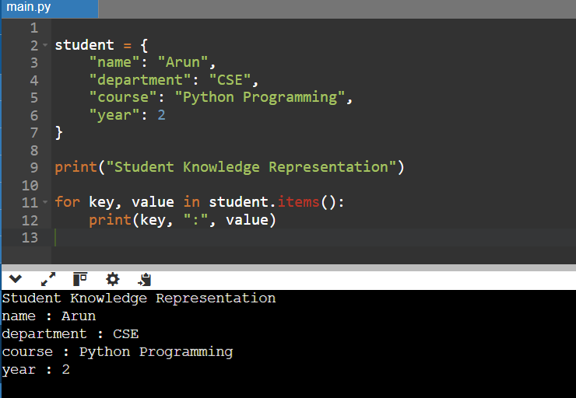
RESULT: Knowledge was represented as structured facts and displayed successfully.

EXP-2 Knowledge Acquisition
Aim: To acquire knowledge from a user and store it as structured facts.
Software Required: Python 3.x
Procedure / Algorithm
4. Read the expert&#39;s name, domain, and years of experience.
5. Store the values in a dictionary.
6. Display the acquired knowledge.

Program
name = input(&quot;Enter expert name: &quot;)
domain = input(&quot;Enter area of expertise: &quot;)
experience = int(input(&quot;Enter years of experience: &quot;))
knowledge = {
&quot;expert&quot;: name,
&quot;domain&quot;: domain,
&quot;experience&quot;: experience
}
print(&quot;\nAcquired Knowledge&quot;)
print(&quot;Expert:&quot;, knowledge[&quot;expert&quot;])
print(&quot;Domain:&quot;, knowledge[&quot;domain&quot;])
print(&quot;Experience:&quot;, knowledge[&quot;experience&quot;], &quot;years&quot;)
OUTPUT:
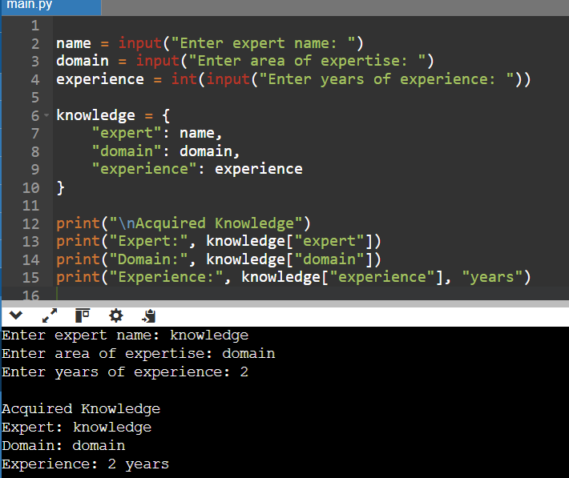
RESULT: Knowledge was collected from the user and stored in a structured form.

EXP-3 Knowledge-Based Course Recommendation System

Aim: To recommend a course using a small knowledge base and decision rules.
Software Required: Python 3.x
Procedure / Algorithm
7. Read the student&#39;s area of interest.
8. Compare the interest with predefined conditions.
9. Display the recommended course or a fallback message.
Program
interest = input(&quot;Enter your interest (AI, Data, Web): &quot;).strip().lower()
if interest == &quot;ai&quot;:
course = &quot;Artificial Intelligence&quot;
elif interest == &quot;data&quot;:
course = &quot;Data Science&quot;
elif interest == &quot;web&quot;:
course = &quot;Web Development&quot;
else:
course = &quot;No matching course found&quot;
print(&quot;Recommended Course:&quot;, course)
OUTPUT:
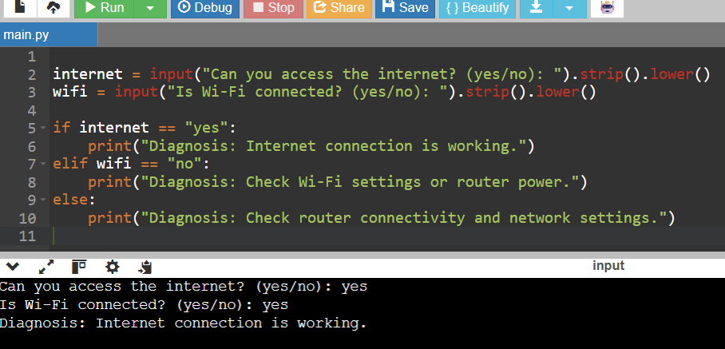
RESULT: The system used stored knowledge and rules to produce a recommendation.

